Mayor Ted Wheeler Changed His Mind About the First Amendment, More Than Once

(This was written in June 2017….yes Ted Wheeler has been unsupportive of the police for a long time,)

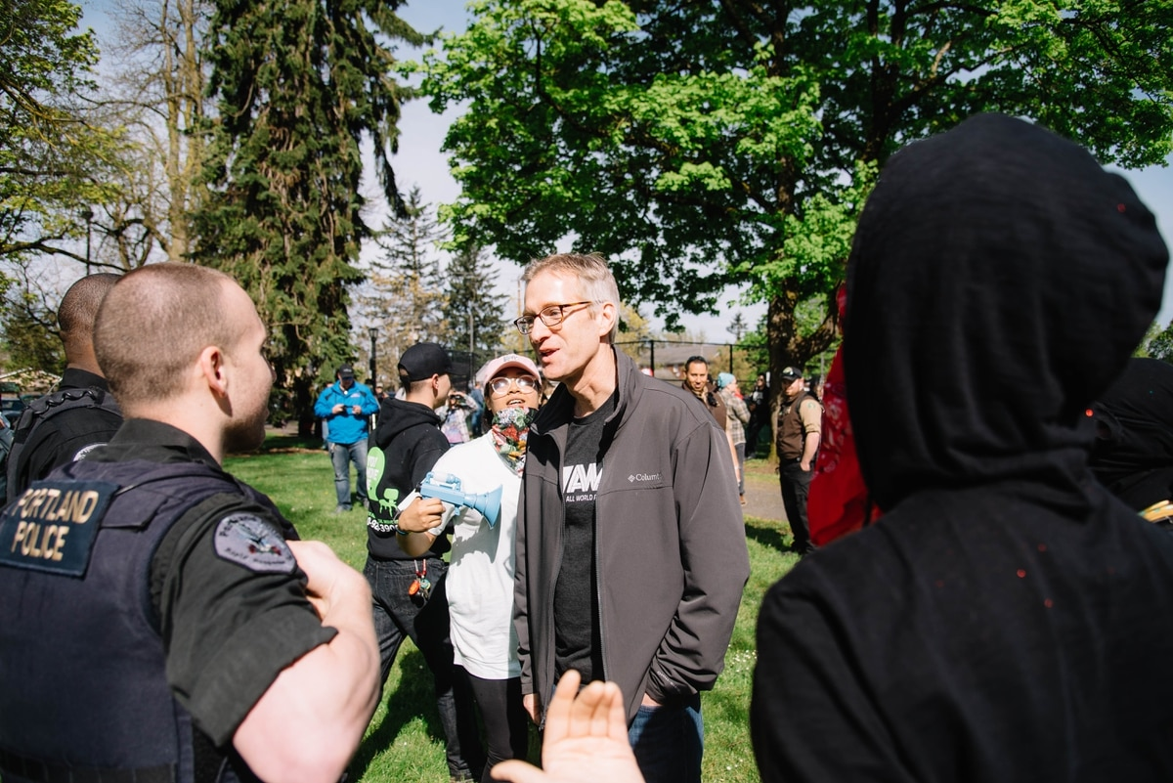Mayor Ted Wheeler talks to police while taunted by protesters on April 29, 2017. (Joe Michael Riedl)

Hate speech is not protected," the mayor said. But it is.
Portland Mayor Ted Wheeler took several positions on the First Amendment during the past two weeks.
None of them worked.
On May 29, Wheeler asked the federal government to block a downtown Portland rally organized by right-wing protesters, saying visiting extremists had no legal right to hate speech. That request was denied by the feds, decried by civil liberties watchdogs, and sneered at by "alt-right" leaders.
Worse, he was wrong: The protections of the U.S. Constitution are designed to forbid the government, including Portland mayors, from deciding what citizens can and cannot say, even when it is deeply offensive.
By this week, Wheeler's office reversed itself again, saying the mayor had misspoken.
Here's what he said.
Wednesday, May 24
In a WW story on the street brawls that had already occurred between alt-right and antifascist groups, Wheeler's spokesman Michael Cox said:
"Portland is going to continue with our strategy: honoring First Amendment rights while not tolerating acts of violence, vandalism or blocking transit."
Monday, May 29
Three days after a double murder on a MAX train, Wheeler called for revoking federal permits for the alt-right rally:
"My main concern is that they are coming to peddle a message of hatred and of bigotry. And I am reminded constantly that they have a First Amendment right to speak, but my pushback on that is that hate speech is not protected."
Wednesday, May 31
Wheeler wrote an op-ed in USA Today, backing away from his interpretation of the Constitution from a day earlier:
"I am a firm supporter of the First Amendment. While this planned demonstration is constitutional, it is highly irresponsible."
Monday, June 5
Cox said Wheeler didn't really mean hate speech was unconstitutional:
"He was being a being a bit imprecise. He was really talking about words meant to incite violence."

